Contributor: Alice Heeren

**Clark, Lygia**

**(Belo Horizonte, 1920 – Rio de Janeiro, 1988)**

Lygia Clark was born in 1920 in Belo Horizonte. She studied with Roberto Burle Marx before leaving for Europe to learn from Fernand Lèger. During the 1950s, she was part of the Grupo Frente and as other artists in the group she would soon begin to subvert the rationalist premises of concrete art and experiment with materials, space, and collaborative practices. From the early stages of her abstract art, Clark was concerned with the need for totality in the work, in creating a living “thing.” The Bichos (Critters 1960-6) are among Clark’s most influential works and they materialize these concerns; the artist perceived them as having their own will instead of being completely passive to manipulation. Clark argued that the Bichos, more than simple artistic objects, initiate and are active subjects in the viewer’s experience. Clark, like other artists from this generation such as **Hélio Oiticica** and **Lygia Pape**, took the teachings of iconic modernists like Piet Mondrian, Max Bill, and Kasimir Malevich, and elaborated on them to arrive at a practice that walked the line between activism, participatory and therapeutic practices.

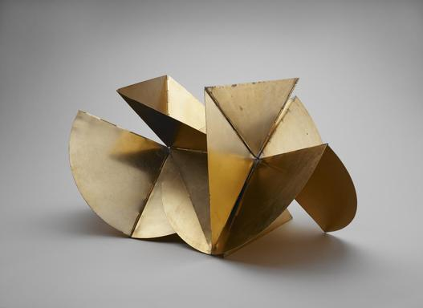

LYGIA CLARK

Brazilian, 1920 - 1988

*Bicho (Máquina)*

*Critter (Machine)*

1962

Gilded metal with hinges

(variable): 21 x 35 1/2 x 21 1/2 in. (53.3 x 90.2 x 54.6 cm)

The Museum of Fine Arts, Houston

The Adolpho Leirner Collection of Brazilian Constructive Art

<http://www.mfah.org/art/detail/bicho-maquina-critter-machine/>

Clark’s Superfícies Moduladas (Modulated Surfaces, 1956) highlighted the constructivist influence of Clark’s early training, but already showed her experiments with what she called the organic line and how it intervened in the space of the work opening it up to the world outside. The change in the titles of the artist’s work—from lifeless inorganic to organic living things—in the end of the 1950s consolidate this change: from her Units (1958) to the Linear Egg (1958). The light-lines created an illusionistic depth in the two-dimensional plane of the painting, and Clark uses this illusion as a tool to break from the frame.

Folding out the plane into itself, she created the Casulos (Cocoons, 1959), her first breach into the “world.” Around the same time, influenced by Vladimir Tatlin, she created her own Counter-Reliefs, which in turn were the major inspiration for the Bichos (Critters, 1960-66). This question of the experience, of a relational event in space and time, was already part of her work, but takes full form in Caminhando (Walking, 1963). In this piece, Clark instructs the participants to fold a strip of paper and attach it to itself forming a Mobius strip. Then, by using a pair of scissors, cut the length of the strip continuously until you are left with only a line too thin to cut further. Like the Bichos, Caminhando is a participative event; the viewer is asked to engage with an object that shapes the experience, demanding answers from him. The Cloth-Body-Cloth series of 1966, draws from these earlier works, but expands them as the object becomes a surrounding space, and the event involves others. Now, the participant is invited to relate to the object, the other, and the environment that surrounds him. Choice, agency, and the space where the event occurs are central to the propositions. The artworks are also agents, however, and not objects of the experience; the process is generated by the object’s characteristics and its interaction with the participant. Like in Clark’s account of the Bichos, it is important to remember their own will.

Clark’s Cloth-Body-Cloth series was produced around the time the artist was working with garments, as well as accessories such as goggles, masks and gloves. On the outside, these were apparently simple objects made up of plastic, fabric or rubber; nevertheless on the inside, in contact with the person’s skin, were textured materials. Clark had previously produced quasi-architectural works such as Construa você mesmo seu espaço para viver (Build yourself your own place to live, 1963), as well as other garments. The I and the You can be seen in relation to these architectural works: as places to live. The dematerialization and demystification of the art object are central aspects of Clark’s later work with her objects becoming supports for actions instead of the end of the artistic process. These objects became key to her therapeutic interventions and towards the end of her life Clark turned to psychoanalysis practices focusing on her clinical practices.

Lygia Clark is today one of the most well know Brazilian modern artists with monographic exhibitions such as “Lygia Clark” at the Fundación Tapies and “Lygia Clark: The Abandonment of Art 1948-88” at the Museum of Modern Art in New York. Her work is also part of important collections in international institutions such as the Tate Modern, The Museum of Fine Arts, Houston and MoMA.

References and Further Reading:

CLARK, Lygia (1999). *Lygia Clark*. Curadoria Paulo Herkenhoff; texto Paulo Herkenhoff. São Paulo: MAM.

CLARK, Lygia (1998). *Lygia Clark*. Introdução Manuel J. Borja-Villel; texto Guy Brett, Paulo Herkenhoff, Ferreira Gullar. Barcelona: Fundació Antoni Tàpies,.

MILLIET, Maria Alice (1992). *Lygia Clark: obra-trajeto*. São Paulo: Edusp.

FIGUEIREDO, Luciano (org.) (1996). *Lygia Clark, Hélio Oiticica: cartas: 1964 - 1974*. Rio de Janeiro: UFRJ.

FABBRINI, Ricardo Nascimento (1994). O espaço de Lygia Clark. São Paulo: Atlas.